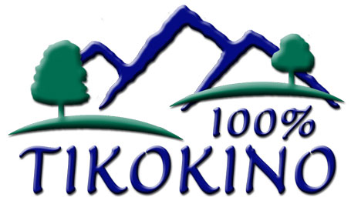
Board Self Assessment Checklist

Please complete the following self assessment individually and anonymously.
 | YES | NO | DON’T KNOW | Comment
1. Our mission/vision/purpose statement clearly communicates what we want to achieve
2. Our values and beliefs are clearly stated and reflected in all our programs and activities
3. We have a strategic plan that guides our Board, staff and volunteers.
4. Our board and committee meetings are well-attended
5. Conflicts among trustees do not interfere with the Board’s work.
6. Most Board members attend our social functions
7. Our financial monitoring and control systems enable us to quickly identify errors and protect us from most criminal activities.
8. The Board’s relationship with the Principal is one of mutual trust and respect
9. The roles of Board members and Staff complement each other, and do not conflict.
10. Our Principal’s performance is evaluated frequently enough.
11. Board members make up an effective team that works well
12. Our financial expenditures are in line with our objectives and priorities.
13. Our Principal gives us the information that we expect and need to evaluate our school’s performance
14. Board meetings are a positive time where everyone is able to contribute within an inclusive environment
15. The board provides adequate orientation, training, and evaluation for Board members.
16. The Board has adequate measures to prevent conflicts of interest.
17. We abide by our code of behaviour
18. We have reason to be optimistic about our ability to deal with whatever the future brings in the next 3 years.
19. I am proud to be a trustee of this school.

In my view these are the things our board is doing well:

In my view these are the things our board needs to improve:

Any other comments?

