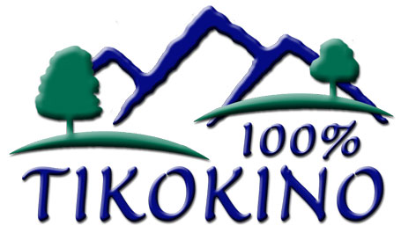
NAG 2

TIKOKINO SCHOOL

SELF REVIEW

PROCEDURE: Consultation with the Community
Tikokino School has a commitment to making consultation with the community a realistic, satisfying, and sustainable process. It sees consultation as a major step in developing a collaborative relationship with the community which will enhance learning.

GUIDELINES:
- A welcoming school atmosphere which acknowledges the value of parents support
will be encouraged.

- Opportunities to inform and to encourage parents to visit and communicate with the school will be fostered.

- Consultation will be an on-going part of school life rather than a series of unrelated additional tasks.

- For effective consultation the school must:
- ensure the parties involved fully understand the consultation process
- develop a commitment from those involved
- select meaningful issues to work on
- draw on people’s strengths and interest
- give people prompt feedback and well publicised and constructive action.

- Efficient processes for gathering, collating, analysing and reporting information and opinions are a prerequisite of effective consultation.

- Consideration should be given to using culturally appropriate styles and venues in the local community to meet with parents.

- The school should be responsive to the various methods of consultation such as
- Board newsletters to the community after board meetings
- School newsletter from the Principal
- Annual meetings of the Board
- Three Way Conferences
- Students’ work displayed
- Parent / Community open forums
- Sending surveys home
- Sending policies home for feedback
- Personal Education Pathway Books
- End of Year Written Reports

