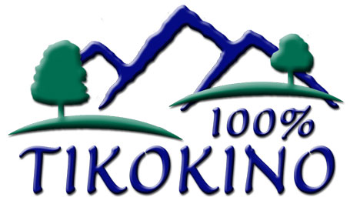
NAG 2

TIKOKINO SCHOOL

SELF REVIEW

05/07

PROCEDURE: Strategic Plan

GUIDELINES:

- Following a Community Consultation Process with parents and caregivers, areas for development will be identified for inclusion in the 3 to 5 year Strategic Plan

- The Board of Trustees will meet to discuss ideas for future development in the school, and to set priorities.

- Following this, a draft Strategic Plan will be developed, and sent to Parents, caregivers and staff asking for comments and ideas.

- The Board considers any suggestions given, and alters if necessary.

- The Strategic Plan is:
- subject to amendments and additions at any time;
- subject to practical, financial and time constraints.
- to be used as a guide for the Annual School Development Plan to set priorities to ensure the overall 3 to 5 Year Strategic Plan is achieved.

