NAG 5

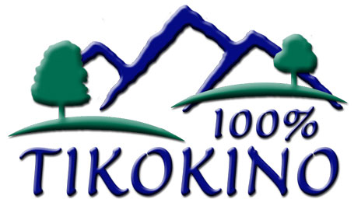
TIKOKINO SCHOOL

HEALTH AND SAFETY

PROCRDURE: Sunsmart

RATIONALE

To ensure that children attending Tikokino School are protected from skin damage caused by harmful UV radiation from the sun, as this can lead to skin cancer in later life.
This policy is to be implemented in Terms 1 and 4.

GUIDELINES:

- To ensure that there are enough shelters and trees providing shade in the school grounds particularly in areas where students congregate.

- Work with the wider school community to promote students’ use of SPF30+ broad spectrum, water resistant sunscreen. Sunscreen will be available at school for those children who do not bring it.

- Encourage the daily application of sunscreen prior to the lunch break and outdoor activities.

- All children are issued with a School bucket hat (minimum 6cm brim, deep crown) for their use throughout Term 1 and 4 when they are outside.

- Tikokino School will have a “No Hat, No Play” policy ie, students without hats are required to sit in a designated area in the shade.

- Children and staff will be encouraged to wear clothing that protects the skin from the sun (e.g sleeves and collars.) Staff are encouraged to role model SunSmart behaviour

- This SunSmart Policy will be publicised and reinforced through newsletters, and at student and teacher activities

- When enrolling their child, parents will be:
  - Given a copy of this SunSmart Policy
  - encouraged to use a SPF 30+ broad spectrum, water resistant sunscreen during summer
  - asked if their child has any known allergic reactions.

- Sun Smart education and activities will be incorporated at all levels when delivering the curriculum. It will be reflected in the planning of all outdoor events and wherever possible to minimise time outdoors between 10am and 4pm.

- Prevention is best. The best method of ensuring students are protected from the UV light is when they are motivated, through education, to take care of themselves.

