NAG 4


TIKOKINO SCHOOL

3/14

PROPERTY

PROCEDURE – Ultra Violet (UV) Treatment plant

All instruction booklets for the pumps, UV Treatment plant etc are in the Pump Shed.

GUIDELINES:

- Details of the UV treatment plant –
- UV System is NSF Compliant Trojan UVMax Pro 10 and Commcentre sensor (24 month lamps set).
- Quartz sleeve (part number #602854)
- Lamp (part number #602854)
- UV Sensor (part number #602580)

Details of filter -
- Cartridge filter
- 1 x 10” BDG 25-01 (Part 10”BDGD) Micron Polyspun cartridge

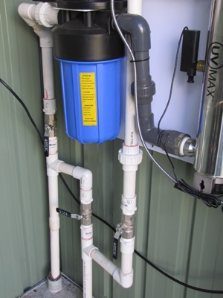
- The Filter is to be changed every term

Normal operating positions for handles as in photo
      - tap 1 – open
      - tap 2 – closed
      - tap 3 – open

To change filter and for UV repair positions for handles
      - tap 1 – closed
      - tap 2 – open
      - tap 3 – closed

- press red button on top of filter
- undo and change filter
- cleaning the inside of the plastic cover.

- The UV Lamp is to be changed every 24 months

4) Record dates of maintenance carried out.

5) If the UV (MAX) plant begins to beep, and the lights on it change to orange or red, follow the sign on the little screen.

While water is running into the tank, (essential) by pressing the black button at the bottom of the black cylinder that protrudes from the stainless steel UV MAX cylinder, and waiting for it to build up pressure (about 5 to 10 seconds) this appears to do a self cleanse of the UV light and returns the lights to green.

(Water must be running through the UV lamp and into the large tank for this to work. Either climb up a ladder on the library side of the tank, and lift the string that is attached to the weight to make this occur, or try turning a tap on in the school.)

For maintenance work that is beyond the above guidelines and requires further assistance, please contact:
Panton Plumbing, 107 Stoneycroft St, Hastings 06 876 5057
(Rex 021 459166)

